## Exercise 07: Making a medical questionnaire (6) - Data sensitivity and obligatory fields

* Mark first name as identifier

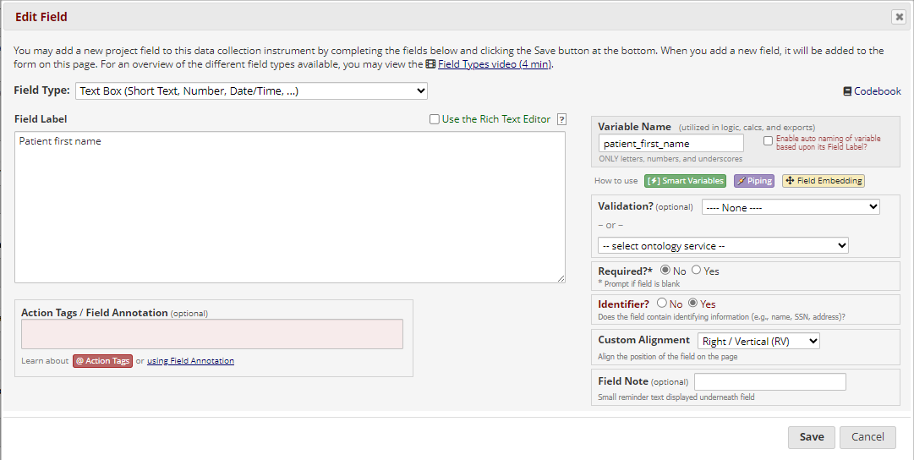

* Mark last name as identifier

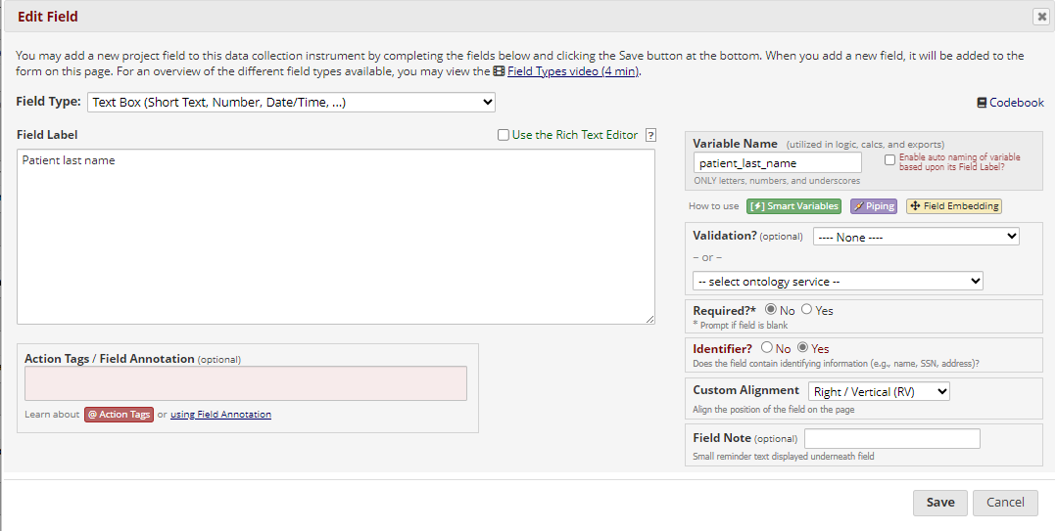

* Mark email address as identifier

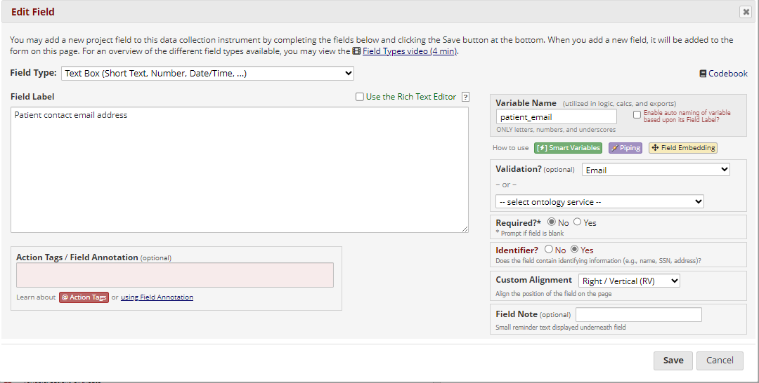

* Mark birth date as identifier

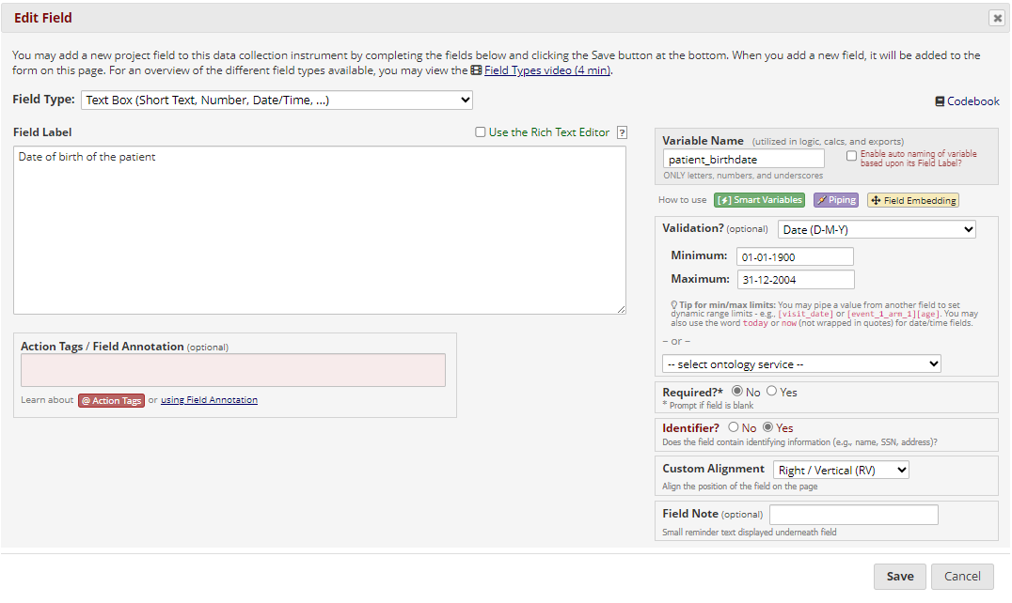

* Mark the email address as required

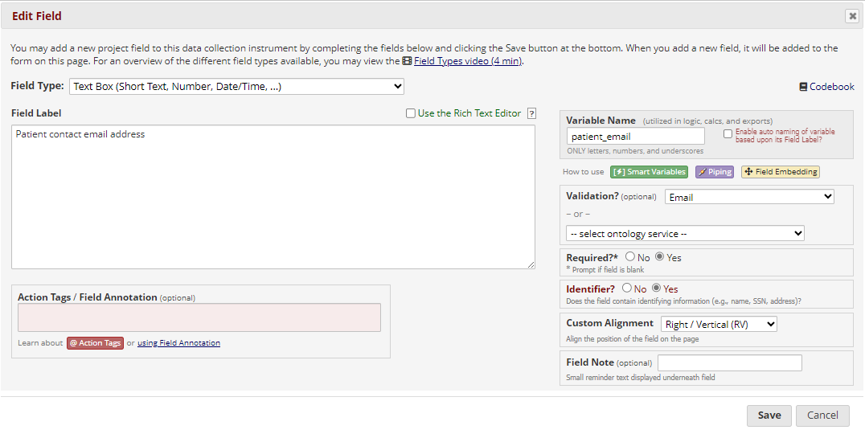

* Mark the health_overall field as required

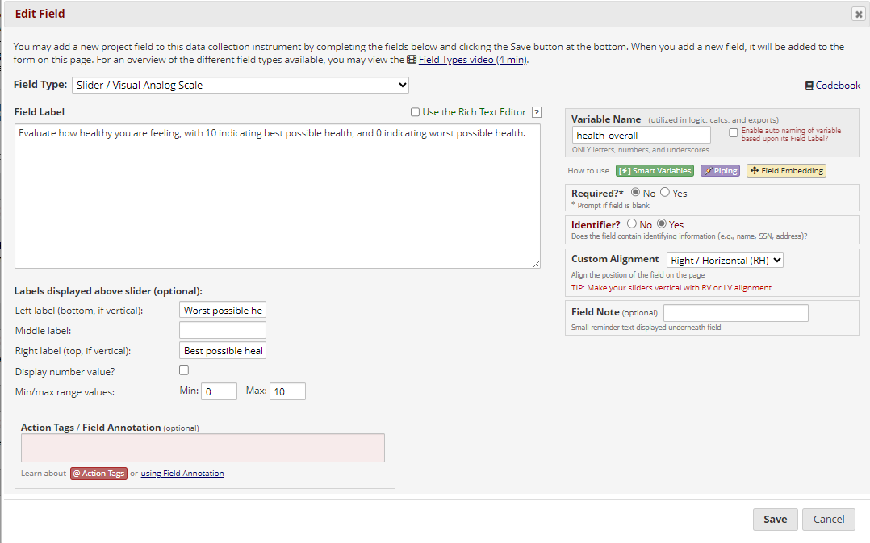

* Create a snapshot of the instruments

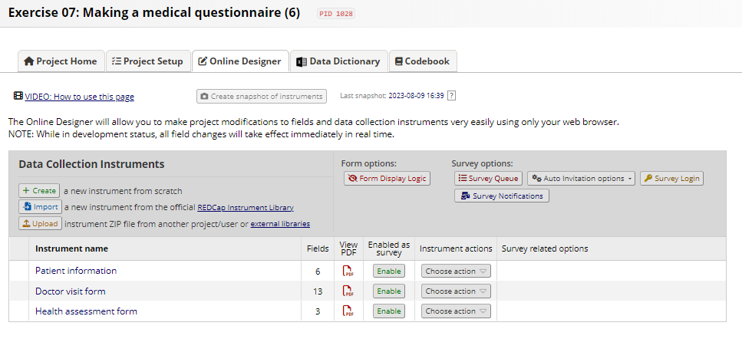

* Indicate that the design of the survey is ready

